Shift-Left Approach

1-What is Shift-Left Approach
# Source: AI Source: Provided by: [Data Path: Persons Table -> ID Column: 1, Name_En Column: Motasem Essam] -> From: [Chatgpt (GPT‑5 Mini)] on [8/22/2025]
The Shift-Left Approach in software development and testing means moving testing and quality activities earlier ("to the left") in the development lifecycle — so issues are found and fixed as early as possible.

2-Why “Shift Left”?
# Source: AI Source: Provided by: [Data Path: Persons Table -> ID Column: 1, Name_En Column: Motasem Essam] -> From: [Chatgpt (GPT‑5 Mini)] on [8/22/2025]
- In a traditional (Waterfall) process, testing happens at the end — after coding is complete.
- This often means:
  - Bugs are found late (when they’re more expensive to fix).
  - Release schedules are delayed.
  - Quality problems escape into production.
- By shifting testing left (earlier), you detect and fix problems while they’re still small and cheap.

3-Core Idea
# Source: AI Source: Provided by: [Data Path: Persons Table -> ID Column: 1, Name_En Column: Motasem Essam] -> From: [Chatgpt (GPT‑5 Mini)] on [8/22/2025]
- Don’t wait until the end to verify quality.
- Start quality checks from the very first stages: requirements, design, coding.
- Testing becomes continuous rather than a separate phase.

4-How It Works
# Source: AI Source: Provided by: [Data Path: Persons Table -> ID Column: 1, Name_En Column: Motasem Essam] -> From: [Chatgpt (GPT‑5 Mini)] on [8/22/2025]
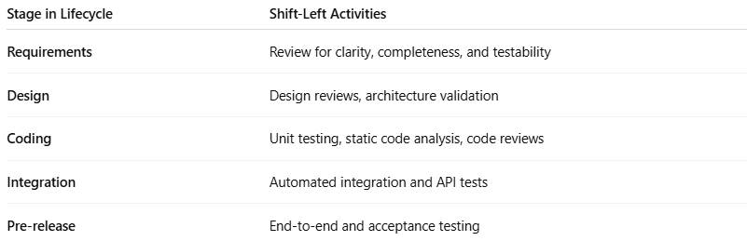
Stage in Lifecycle | Shift-Left Activities
Requirements | Review for clarity, completeness, and testability
Design | Design reviews, architecture validation
Coding | Unit testing, static code analysis, code reviews
Integration | Automated integration and API tests
Pre-release | End-to-end and acceptance testing

5-Benefits
# Source: AI Source: Provided by: [Data Path: Persons Table -> ID Column: 1, Name_En Column: Motasem Essam] -> From: [Chatgpt (GPT‑5 Mini)] on [8/22/2025]
- Early bug detection → Fixing a bug found during coding is far cheaper than in production.
- Faster feedback → Developers know quickly if they broke something.
- Better quality → Continuous quality assurance at each stage.
- Reduced costs → Early fixes cost less time and money.

6-Example
# Source: AI Source: Provided by: [Data Path: Persons Table -> ID Column: 1, Name_En Column: Motasem Essam] -> From: [Chatgpt (GPT‑5 Mini)] on [8/22/2025]
Without Shift Left (Traditional):
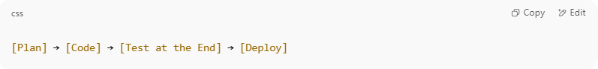
[Plan] → [Code] → [Test at the End] → [Deploy]

Bugs found here are late, expensive, and risk deadlines.
With Shift Left:
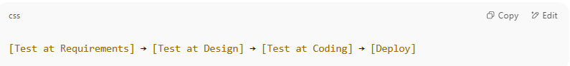
[Test at Requirements] → [Test at Design] → [Test at Coding] → [Deploy]

Bugs are found and fixed earlier, reducing risk.

7-In DevOps & Agile
# Source: AI Source: Provided by: [Data Path: Persons Table -> ID Column: 1, Name_En Column: Motasem Essam] -> From: [Chatgpt (GPT‑5 Mini)] on [8/22/2025]
- Shift-left is implemented with automated testing in CI/CD pipelines.
- Includes unit tests, static analysis, API tests, and early integration tests — all run before deployment stages.

